//BLUE TOWN - ROSE//

Aadarsh looked up to the sky as he was playing with his mother Kalpana in the open snowy plains.

Aadarsh: Ma! Inaiku yen ivlo irutta iruku ippavey?

Kalpana: (joyful) Adhaan yenakum therila. Aana super-ah iruku laaaa!

Aadarsh: (excited) Aama!! Podu! Super-ah iruku! Shreesha paathiya-ma?!

Kalpana: (screaming, excited) Illaaa!!! God-friend kooda yengayadhu poirupa!

Upon screaming, Kalpana threw a snowball at Aadarsh.

Aadarsh: (smiling) Okayyyyy!

Aadarsh threw back another snowball on Kalpana. They both laughed out loud.

//Cut to//

//NEVA SANCTUARY//

BK, Divakar and Anushri were standing around Gardener. The Acanus with pink flower on its head was also standing with them.

Anushri: (curious) Ayu! Gardener ku yenna airukum?

BK: Oru vela pudhusa yedachu kandupudichitara yenna? Divakar nee yenna nenaikura?

Divakar: Yenaku therila. Odambu yellam karupah mariduchu. Yepdi…?

Anushri (enthusiastic): Oru vela pudhu power-ah irukumo?!

BK: Aana yen yendhirika matinguraru?

Anushri walked closer to the Gardener and shouted in his ears

Anushri: G-A-R-D-E-N-E-R

The Gardener suddenly let out a sharp loud sound as if a person is suffering for air.

Gardener (struggling): Kaa- (leaving sharp sound)

His conscious faded along with the sharp sound

Anushri, BK and Divakar gave a confused look.

Suddenly they burst into laughter.

Anushri: Ayu! Ayu! Adhu nalla irundhuchula… (mimicking Gardener’s sound) “Kaa-” (mimicking the sharp sound)

Divakar: Anushri… unaku andha Golden rosoar fruit yenga irukunu theriyadha?

Anushri: Gardener ku dhaan theriyum adhu yenga irukunu.

BK: (smiling) Gardener, yendhiringa! (muttering)

Ansuhri: Yen yendhirika matinguraru?

BK: Sari, namma ivara Majesty Kaviya ta kootitu povom! Kandippa inaiku oru pudhu visayam namma therinjukuvom!

Divakar: (smiling) Kandippa.

Anushri: Ayu! Ayu! Yenaku romba sandhosama iruku kekumbodhey!

BK: Podu! Yenakkum! (BK and Anushri high-fived)

//Cut to//
//LAVENDER FOREST - LATE AFTERNOON//

The sky was filled with mist. While the sun has mildly lit one direction with reddish pink colour, on the other side the moon, bigger in size, started to dimly lit in a white-blue dark atmosphere. The beads in the tree glowed because of the dim moon light. Faint purple glow surrounded the area. Nithish wore the white gown for girls and was searching for something in the white bushes around.

Nithish: Ponnunga dress naalum, nalla kulur thaangudhu. Angitu ingitu navuradhukum vasadhiya dhaan Iruku.

White-dressed girl: (shouting as she was searching at a distance) Yenna kedachuda?

Nithish: (shouting) Illa.

White-dressed girl: Anga poi thedu appo.

Nithish: (thinking) Theriyama yenna venalum seiren-nu solli naaney vangi kattikuran. Oru manneram-ah onnum illadha visayatha poi theditu irukan. Inga thedu, anga thedu-nu oru kilometre pakkam vandurupan.

White-dressed girl: (shouting) Nalla thedu.

Nithish: Confirm-ah theriyuma gold colour-dhaan andha pazham-nu?

White-dressed girl: Gold colour dhaan. Thedu indha yedathula yellow colour la yedho pathannu sonnanga.

Nithish: Indha yedam-na yendha yedam? Oru mile pakkom theditom. Enaku vera kulura aaramikudhu.

White-dressed girl : Oru mile dhaana thedirukom. Innum pathu padananju mile aachu thedanum.

Nithish: Pathu padananja?! (thinking) Idhuku na andha kuluralaye sethurukalam.

At that moment, Nithish saw something glowing yellow inside a bush.

Nithish: (thinking) Kandupudichitan-nu nenaikuran.

He let his hand inside slowly. The White-dressed girl quickly walked towards him.

Nithish: (confident) Yeduthutan

There was a yellow fluffy ball-like creature with its soft fur mixed with glowing white. It had long ears pointing high and round sparkling eyes radiated joy.

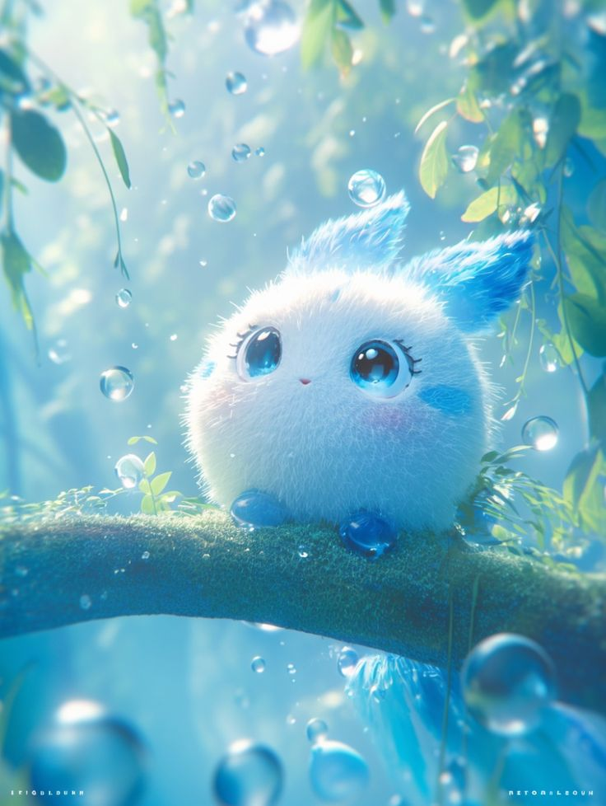
Nithish looked at it holding in his hand.

It let a sound “Ow”

Nithish: Yeiii alaga irukuuuu!!

White-dressed girl: (annoyed) Idhadhan yeduthiya?! Adha keela vittutu olunga thedu, po.

Nithish’s smile faded as her cold words snapped him back to his grim reality.

A sharp throb of pain from the fresh sword wound on his back flared up, reminding him of exactly how helpless he was.

He looked down at the tiny creature in his cuffed hands, but his mind violently drifted back to Earth.

Nithish: Aatha… Kavitha.. Rendu perum ippo yenaya theditu irupanga dhana… Ragul, avanala dhan na inga vandhu maatikitan. (raging) Avan mattum unmaiya sollirundhu idhu yellam nadandhurukadhu!

A massive, suffocating surge of frustration and pure, helpless anger boiled in his chest over being trapped in an alien forest, forced to look for a random fruit, while his life fell apart.

As his temper silently spiked, the tiny creature in his hand suddenly reacted to the dense, overwhelming wave of his Emotional RI. In a fraction of a second, the creature swelled to double its size. Its soft fur bristled aggressively like needles, and it began glowing a volatile, blinding orange.

Startled by its sudden weight and heat, Nithish dropped the creature into the snow.

The White-Dressed Girl watched the creature scurry away, her eyes narrowing in realization.

WDG: Unnoda kova-kaaran emotions adha feed pandrudhu. Amaidhiya iru, kannuku theriyadha aabatha inga izhuthutu vandhuruva.

Her voice brought him back, his face a saddening expression as he left it down. But it stood near his legs and looked at him.

Nithish: Idhu yennadhu?

White-dressed girl: Idhunga Ri adhigama irukura yedathula paakalam.

Nithish: Ri-ah?

White-dressed girl: Ri na… indha marathula yellam minukudhula, adhula yellam Ri adhigama irukunu arthom. Adhanala indha kaatula idhunga konjo nerayavey irukum.

Nithish: Idhu yennoda kaalaye suthi vandhutu iruku.

White-dressed girl took it and threw it far away. The creature gave a happy ‘Ow’ as it flew and fell far away.

Nithish: Yenna pandra?!

White-dressed girl: Adhungaluku onnum aagadhu.

Nithish gave an annoyed look at White-dressed girl and continued searching.

Nithish: Yeppola irundhu nee indha pazhatha theditu iruka?

White-dressed girl: Pathu varshama.

Nithish: (shocked) Pathu varshamava?! Yedhuku ivlo serama pattu idha theditu iruka.

White-dressed girl stood still and looked Nithish in his eyes. She blinked for a moment and went into deep thinking. And then she continued searching.

Nithish let out a frustrated sigh.

Nithish: (continuing to search) Yellathaiyum manasukkulaiye adachu vecha, adhu apdiye maranju yellam pogadhu. Namma kaala yedachu periya mullu kuthuchu nu veiyen, apdiye utta adhu maranju poiduma yenna. See-dhan pudikum. Adha ulla pothi pothi vekkama veliya yedutha dhaan kaal seri aagum. Adhu yevlo seekram veliya yedukkuramo avlo nalladhu.

White-dressed girl’s eyes softened as she was searching while listening to Nithish’s rant.

Nithish: Yellartayum sollanum-nu avasiyam illa. Yellarum adha purinjika maatanga.

Nithish: Yellarutaiyum sollanum-nu avasiyam illa. Adhukunu oruthar koodava–

White-dressed girl: (her eyes wet, voice low) Yaarumey yenna purinjikala. Oruthar kooda… yennoda nelamaya purinjikala.

Suddenly her memories pop up:

A glamorous woman stood confidently in the snow near the stand alone large white tree, her platinum hair flowing over one shoulder. She wore a tight, shiny black outfit with a big, fluffy fur cape. Her large earrings, long necklace, and big sunglasses made her look fancy.
The platinum haired woman (PHW) looked at the young White Dressed Girl (White-dressed girl), as she tried to drag her cart from the water with her small hands.The small wolf also helped her pushing White-dressed girl’s clothes were torn here and there and her leg was bruised with blood.
White-dressed girl: (dragging the cart) APPa… APPa… (breathing heavily) APPa…
The PHW went near White-dressed girl and helped her take the cart out.
White-dressed girl: Appa… ulla maatikitaru. Gold… Golden… Rosoar… pazham venum. Golden Rosoar venum. Appo-dhan… appa thirumba varuvanga.
PHW: Odambu mulusa Ratham. Guard illa?
White-dressed girl: Appa… appa ulla maatikitaru. Periya karuppu maanushangalam ulla irundhanga. Avunga pudichi vechutanga appa va. (gasps) Golden rosoar pazham venum.
The PHW tapped her finger. The sword with the golden handle, which White-dressed girl has now, hovered in front of PHW. She gave the sword to White-dressed girl.
PHW: (firm) Sanda podu.
White-dressed girl looked at her with a sense of fear and confusion.
White-dressed girl: (crying) Appa…
PHW: (firm) ADI. SANDA PODU. APPODHAN JEIPA.
White-dressed girl suddenly stopped whining and was silent. The PHW pressed on the sword.
//Transition - PRESENT//
Nithish stood silent, hearing her words. Then as he went to continue searching, White-dressed girl spoke.
White-dressed girl: Yenaku pathu vayasu irukum. Nanum yen appa-vum sandhosama (her eye filled with water) oru madhiyana time-la pazham yellam porichitu, apdiye veragu yellam yeduthutu vandhom. Thideernu yedho oru velicham yenga pakkathula vandhuchu. Thideernu paatha naanga vandha vandi sarukki mazhai-la irundhu thanni ulla vilundhuruchu. Appo dhan andha yedathuku modhala ponom.
//Transition - Flashback//
//EXTERIOR - UNDERWATER WORLD//
A dark wide place illuminated in blue with only crystals and the sound of waterfalls echoing.
They came out of the mist. At first, they were just shapes, but they formed into tall, thin beings made of twisting black vines. Their eyes were points of burning, evil blue light. One figure, larger than the rest, glided forward. Its body wasn't solid, but a shifting mass of large liquid shadow, with dark tendrils twisting and pulling back.Young White-dressed girl and her father were caught by one of the black vined creatures. Her father was wounded badly and was unconscious. The Large Liquid Shadow (LLS) with its other black vined creatures stood before them
White-dressed girl: (frightened) Appa! Appa! Yendhiringa. (to the creatures) Appa-va kaapathuringala. Unga–
One of the creature stretched her wine close to White-dressed girl to kill her. The LLS cut the vine quickly.
LLS: (commanding to the creature) Niruthu.
The creature backed off.
The Large Liquid Shadow (LLS): (to creature, whispering) Nammaluku iva theva. (to White-dressed girl) Kolandha neeye vasama vandhu yenga kitta maatikitiye…
The LLS brought her scary face near White-dressed girl.
White-dressed girl: (eyes widened) Illa… Illa… Yengala vitrunga… (panicking) APPA! APPA!
Her father was unconscious.
White-dressed girl: (crying) Vitrungaaa…..
LLS: Seri. Unna mattum vidran. Aana nee yeppo yenaku andha Golden rosoar pazhatha konduvariyo, appo dhaan unnoda appa-va viduvan. Sariya? Aana adha kandupudikara varaikum, daily-um nee yenaku (LLS looked at other creatures enjoying the fruit that shattered from the cart by just absorbing them with vines) andha pazham oru nooru kondu varanum. Sariya?
//Transition - RED LILY//
People were playing with snow. White-dressed girl stood sad amidst everyone playing happily. She ran to a man.
White-dressed girl: (soft) Anna, Golden Rosoar fruit unga kitta iruka?
The man: Illaye, ma. Yedhuku kekura?
White-dressed girl: Appa ulla ulundhutaaru. Avara kaapathanum. Golden rosoar pazham venum.
The man: Yenga vilundharu unga appa?
White-dressed girl took him to the cascades.
White-dressed girl: (pointing at the water down below) Idhu ulla vilundhutaru.
The man also jumped inside but instead of drowning he was floating. He started to play happily in the water. White-dressed girl watched him float and was confused. The man came back using the Acanus.
The man: Indha yedam matha yedam madhiri dhaan iruku. Idhukulla yedpi unga appa ulundharu?
White-dressed girl: Idhukulla dhaan ponaru.
The man: Appadiya, seri ma. Nee veladu. Na aprom vandhu sendhukuran.
White-dressed girl: Illa… appa… (her eyes were desperate)
She called a few more people each day to the cascades and told them what happened. Everyone left her smiling.
//Transition//
She went to Blue Rose and started asking everyone about the Golden Rosoar fruit. She was tired and her face was full of despair. Then she saw Young Kalpana and BK,who were playing with snow skidding around using kinesis.
White-dressed girl: Anna!
BK approached her.
White-dressed girl: Unga kitta Go-Golden Rosoar palam iruka?
BK: Apdina?
White-dressed girl: Adhu manja colour-la round ha irukum. Yenaku adhu theda udhavureengala?
Kalpana: BK inga paru!!! (She does a flip) Yenna madhiri pannuviya?!
BK: (excited) Yepdi panna?!! Yenakum solli thaa
He ignored White-dressed girl and went to Kalpana
White-dressed girl put her face down and walked slowly.
White-dressed girl: (thinking) Yarumey udhavi panna matiranga… (remembers her father’s face) Illa… appa…
She again goes to Red Lily. She stood in the middle of town sad, while everyone around her played happily. She looked at how every child was happy with her father. One guy was plucking fruits with her daughter. Another one jumped along with her daughter in the valley. Another gave a piggy back ride.
White-dressed girl tightened her hands.
White-dressed girl: (shouting) Yaravadhu udhavungalen!!!
People who were nearby turned around, but continued with their happy playing.
White-dressed girl: (weak) yaravadhu… (tears fell from her eyes) yaravadhu…
White-dressed girl fell to her knees.
Slowly she saw a shadow in front of her.
She tilted her head up. It was young Elijah standing before her.
Elijah: Kan.. kannula yen… thanni… varudhu?
He stretched his hand, a fruit in his palm.
Elijah: Indha… Indha pazham dhaan… yen… yenkitta iruku.
As her hands trembled, she took the fruit from Elijah.
//Transition - now//
White-dressed girl: Oruthar kooda yenaku udhavula… naney dhenamum nooru pazham parichitu ponan. Konjo naal kalichu dhaan Elijah yenaku udhava aaramichan. Apron avan kekradhellam na konduvaran, adhuku badhula avan yenaku red rosoar pazham parichu veppan. Andha madhiri oru naal avungaluku pazhatha kuduthutu thirumba varum bodhu dhaan, naan avala paathan.
//Transition//
//REDWOODS//
PHW: Kenjunalum, udhavamatanga yaarum.
White-dressed girl: (desperate) Neengalavadhu yennoda appa-va kaapathunga. Neenga yenna solraalum na seiran.
PHW: Ippo udhavuna, aprom yenna pannuva.
White-dressed girl: Yennavenalum sollunga seiran
PHW: Unakku purila. Thirumba appa ulundhuta yaaru kaapathuva?
White-dressed girl looked at her eyes hopeless.
PHW: Sanda podu. Balam Adhigam. Appo dha jeika mudiyum. Vaal yedu veliya.
White-dressed girl took her sword out. As PHW tapped her fingers, an axe hovered.
PHW: Adi.
White-dressed girl was confused. Her hands were shaking as she held the sword.
PHW: (screaming) APPA VENUMNA ADI!
White-dressed girl squeezed her eyes and swung her sword fast. It hit the axe.
PHW: Apdi dhaan adi.
White-dressed girl hit again, much strong.
PHW: Nalla adi!
White-dressed girl’s strikes got stronger with each hit.
PHW: Innum.
White-dressed girl hit harder.
Everyday she came to redwoods and they both trained.
She hit the axe. After a certain hit, the axe cracked. PHW smiled at her.
Her training continued day after day. Every evening she came to the same spot to fight with the PHW. After few months the axe was almost broke.
She gave her all in the one last blow as she screamed “HYAAAAAAHH” and the axe broke into two. PHW was glad. She hugged White-dressed girl.
PHW: Nee odachuta. (smiling)
White-dressed girl took deep breaths.
White-dressed girl: Oru-valiya odanjuruchu.
PHW: Modhal adi mudichuta. Ipdi dhaan balam varum. (a pause, serious) Idhu pathadhu. Inimey dhaan neraya adi adikkanum. Andha vaal-ah neeye vechuko. Poran.
White-dressed girl: Yenga poreenga?
PHW: Kadavul iruparo anga.
White-dressed girl’s eyes widened.
White-dressed girl: Yaar neenga?
PHW stood silent for a moment. Then she looked at White-dressed girl in her eyes.
PHW: Thinai, Paal, Yen, Idam, Kaalam yellathaiyum kadandha oru aal naan. ‘Zitabye’.
//Transition - Now//
White-dressed girl: Avunga mattum appo varalana, na yeppaiyo sethurupan.
Nithish: (muttering) Paavom.
White-dressed girl: Yenna?
Nithish gives her a fruit from what he had gathered.
Nithish: Nee pala kasthatha anubavichuruka. Kandippa unaku adhuku oru prize kudukanum. Indha pazham.
She looked at his smiling face, the dim moon light brightening.
White-dressed girl receives it from him, her eyes soft.
White-dressed girl: (her expression changing to stubborn) Parisu yellam irukatum modhala olunga andha pazhatha kandupudi.
Nithish: (muttering) Pesama naney vechurkalam indha palatha
White-dressed girl: Andha padam kedaikalana, yenna pannanum-nu nyabagam iruka?
Nithish: (with a low voice) Iruku… aana na madhiri yendha yedathuku transfer aavom-nu therila.
The White-dressed girl’s face turned thinking.
White-dressed girl: Paravala.

